Donnybrook Medical Services

Communicating with your doctor during a Covid-19 outbreak

The standard face-to-face consultations
Face-to-face consultation can still happen under certain conditions.
The following adjustment are made:
- Extra cleaning and infection prevention by our team
- Patients with symptoms are asked to stay home and a phone/ video consultation will happen first before deciding on a face-to-face consultation.
- Appointments that require more than 15 minutes will be made over the phone/ video first and when needed followed by a face-to-face meeting.
- When you are unable to wear a mask, we cannot see you face-to-face and will need to assess the situation first through telephone or video call.

Telephone consultations
Telephone appointments are available for anyone. Please ask our receptionist if you prefer a phone call.

Video call consultations
Telehealth is available. We use health direct video for our video consultations.

The below link will take you to a digital waiting room. When the doctor is ready for your consultation, you will be taken to a private digital room for your consultation.

https://videocall.direct/donnybrookmedicalservices

To make an appointment for a video call, please ring our receptionist to book an appointment.

Repeat prescriptions.
We prefer patients to present for a standard consultation for repeat prescriptions, this can be done face-to-face, telehealth or video call.

We also have our current call back system in place for repeat prescriptions for regularly attending patients. Please indicate to the receptionist when you like to use this. The callback system for repeat prescriptions is not allocated to a specific time. The doctor calls during breaks or at the end of a session. If you prefer to be called at a specific time, it is best to book an appointment (face-to-face, phone or video call)

Results.
Between 1 and 2 pm on Monday to Friday our nurses are available to take phone calls for results.

What to do when you have symptoms of Covid-19

When you experience the following symptoms, it is important to take action
- Fever
- Cough
- Loss of taste or smell
- Sore throat
- Headache
- Aches and pains
- Difficulty breathing or shortness of breath
- Blue fingers or around the mouth
- Confusion
- Chest pain

What action to take:
- Self-isolate immediately

- Get tested – (see below for testing clinics)

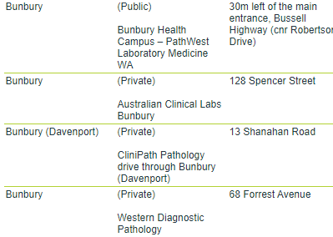
- Monitor your symptoms. Most people who get infected will experience mild to moderate symptoms and can manage at home. If you get seriously unwell you need to seek medical attention. Call 000 in case of an emergency or call you regular doctor. Please do not walk in to a hospital or doctors’ surgery. Special precautions need to be taken.

What to do if you are a close contact to someone who tested positive to covid-19:
Same action as above

What to do if you have been to an exposure site:
Check the exposure website on healthywa.gov.au for instructions for the specific locations.
https://www.healthywa.wa.gov.au/Articles/A_E/Coronavirus/Locations-visited-by-confirmed-cases

Or ring the covid helpline on 13 26 843

For more information go to:
www. healthdirect.gov.au
www. healthywa.gov.au

